Order Of Lenten Service

Opening Hymn: TLH 160

Reading: Lent VII

The History of the Passion of our Lord

Sermon Hymn: TLH 404

Sermon Text: Song Of Solomon 2:16

Total Commitment

Prayer

Holy Communion

The Lord's Prayer

The Blessing

Closing Hymn: TLH 158

* * * * * * * * * * * * *

Bible Study: Lambs: Luke 19:1-10; Climbing A Tree
Sheep: Proverbs 9:7-12



Palm Branches

Water
Of
Life

20 March 2016

W A T E R O F L I F E

Independent Christian Church—Conservative Lutheran Doctrine

Worship Service: 9:30 a.m. Bible Study: 10:45 a.m.

Larry Cooper, Pastor E-Mail address:
111 N. Ridge Road lcooper@wateroflife.cc
Coon Valley, WI 54623 Web Site:
Phone: (608) 452-2105 www.wateroflife.cc

* * * * * * * * * * * * * * * * * * * * * * * * * * *

Sermon Text: Song Of Solomon 2:16

Total Commitment

* * * * * * * * * * * * * * * * * * * * * * * * * * *

Song of Solomon 2:16 My beloved is mine, and I am his: he feedeth among the lilies.

The opening verses of Genesis 22 read this way in the KJV:

Genesis 22:1 And it came to pass after these things, that God did tempt Abraham, and said unto him, Abraham: and he said, Behold, here I am.
:2 And he said, Take now thy son, thine only son Isaac, whom thou lovest, and get thee into the land of Moriah; and offer him there for a burnt offering upon one of the mountains which I will tell thee of.
In Genesis 22:2 we have the first occurrence of the word “love” in Scripture. The teaching here is that Abraham loves Isaac. But Abraham and Isaac are types. Abraham is a type of God the Father, and Isaac is a type of Jesus Christ. So the deeper meaning here is The Father loves the Son.

What is interesting and instructive here is that the words burnt offering also occur in the second verse. In the burnt offering the whole animal was placed on the altar and burned. It indicated total commitment.

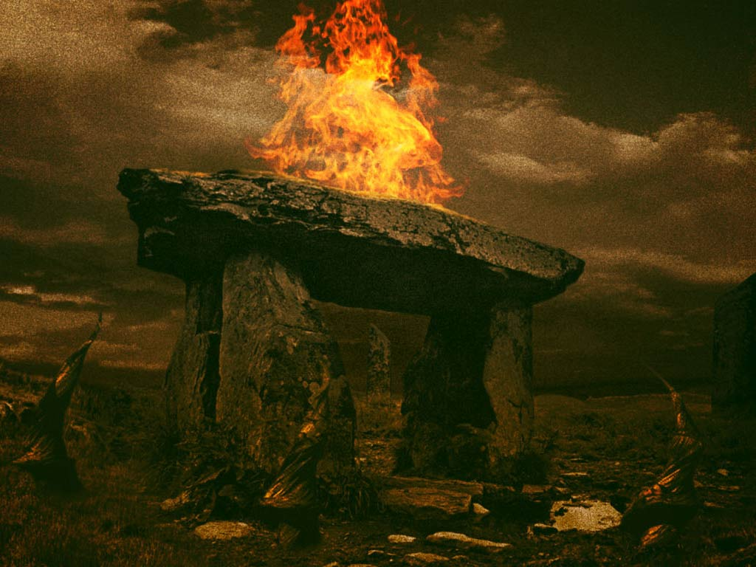

This total commitment is what the Bridegroom, Jesus Christ, gave to his Bride, the Church. “Having loved his own which were in the world, he loved them unto the end.” John 13:1b. And by the grace of God, this is also the total commitment which the Bride gives to her Bridegroom. And so she can say:

My beloved is mine! And I am his!

